Задание 1

[ciborg.brain@yandex.ru](mailto:ciborg.brain@yandex.ru)

1) echo -n "ciborg.brain@yandex.ru" | md5sum

98e62562dff2720681a8452972a572d4

2) echo -n "ciborg.brain@yandex.ru" | sha1sum

5d1f515f96ceb05ae68f6add69e6dd5bca3119f8

3) echo -n "ciborg.brain@yandex.ru" | sha256sum

8cbef34834943602e12ec31dfdd22fcd26bfbfbb30030c3d1c9c4705d7554268

4) echo -n "ciborg.brain@yandex.ru" | sha384sum

f1518c89c88eedb69ef0729a7bc3f463c2d6dfcd848d003b919386045691cff84d4a6f95c8aedc901e0c73f901b62440

5) echo -n "ciborg.brain@yandex.ru" | sha512sum

c16d2e76058bf46382da1a08b4545c019fc47479a3308400a6865fb877931c25762d84ebc765a989ff0b6d55d78743d848b8812802d574da61563a9ade99ff38

Задание 2

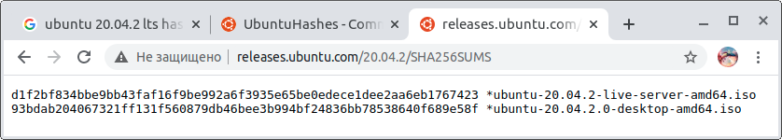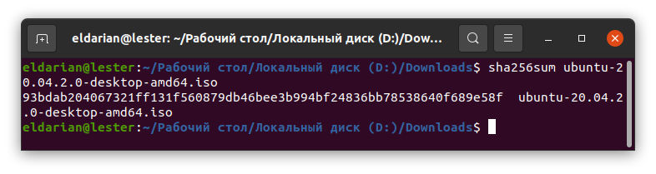

Хеш-суммы Производителя и полученная в терминале — идентичны.

Задание 3

1) echo -n "Эльдар Миннахметов" | base64

0K3Qu9GM0LTQsNGAINCc0LjQvdC90LDRhdC80LXRgtC+0LI=

2) echo -n "0K3Qu9GM0LTQsNGAINCc0LjQvdC90LDRhdC80LXRgtC+0LI=" | base64 —decode

Эльдар Миннахметов

3) Пусть в clean.txt будет содержаться строка «Эльдар Миннахметов», а encode.txt — пустой файл, тогда:

(uuencode clean.txt /dev/stdout) > encode.txt

Содержимое encode.txt:

begin 777 /dev/stdout

DT*W0N]&,T+30L-&`(-"<T+C0O="]T+#1A="\T+71@M"^T+(*

`

end

4) *uudecode -o /dev/stdout* encode*.txt*

*Эльдар Миннахметов*

*Задание 4*

*1)* [*https://i-ts.sirius-systems.ru/*](https://i-ts.sirius-systems.ru/)*- установилось*

*2)* [*https://i-ts-s.sirius-systems.ru/*](https://i-ts-s.sirius-systems.ru/)*- не установилось*

*Задание 5*

*1) curl -i -v https://i-ts.sirius-systems.ru*

*Trying 194.12.56.4:443...*

*\* TCP_NODELAY set*

*\* Connected to i-ts.sirius-systems.ru (194.12.56.4) port 443 (#0)*

*\* ALPN, offering h2*

*\* ALPN, offering http/1.1*

*\* successfully set certificate verify locations:*

*\* CAfile: /etc/ssl/certs/ca-certificates.crt*

*CApath: /etc/ssl/certs*

*\* TLSv1.3 (OUT), TLS handshake, Client hello (1):*

*\* TLSv1.3 (IN), TLS handshake, Server hello (2):*

*\* TLSv1.2 (IN), TLS handshake, Certificate (11):*

*\* TLSv1.2 (IN), TLS handshake, Server key exchange (12):*

*\* TLSv1.2 (IN), TLS handshake, Server finished (14):*

*\* TLSv1.2 (OUT), TLS handshake, Client key exchange (16):*

*\* TLSv1.2 (OUT), TLS change cipher, Change cipher spec (1):*

*\* TLSv1.2 (OUT), TLS handshake, Finished (20):*

*\* TLSv1.2 (IN), TLS handshake, Finished (20):*

*\* SSL connection using TLSv1.2 / ECDHE-RSA-AES256-GCM-SHA384*

*\* ALPN, server accepted to use http/1.1*

*\* Server certificate:*

*\* subject: CN=i-ts.sirius-systems.ru*

*\* start date: Feb 17 07:28:22 2021 GMT*

*\* expire date: May 18 07:28:22 2021 GMT*

*\* subjectAltName: host "i-ts.sirius-systems.ru" matched cert's "i-ts.sirius-systems.ru"*

*\* issuer: C=US; O=Let's Encrypt; CN=R3*

*\* SSL certificate verify ok.*

*2) …*

*Задание 6*

*1) curl -i -v https://i-ts-s.sirius-systems.ru*

*Trying 194.12.56.4:443...*

*\* TCP_NODELAY set*

*\* Connected to i-ts-s.sirius-systems.ru (194.12.56.4) port 443 (#0)*

*\* ALPN, offering h2*

*\* ALPN, offering http/1.1*

*\* successfully set certificate verify locations:*

*\* CAfile: /etc/ssl/certs/ca-certificates.crt*

*CApath: /etc/ssl/certs*

*\* TLSv1.3 (OUT), TLS handshake, Client hello (1):*

*\* TLSv1.3 (IN), TLS handshake, Server hello (2):*

*\* TLSv1.2 (IN), TLS handshake, Certificate (11):*

*\* TLSv1.2 (OUT), TLS alert, unknown CA (560):*

*\* SSL certificate problem: self signed certificate*

*\* Closing connection 0*

*curl: (60) SSL certificate problem: self signed certificate*

*More details here: https://curl.haxx.se/docs/sslcerts.html*

*curl failed to verify the legitimacy of the server and therefore could not*

*establish a secure connection to it. To learn more about this situation and*

*how to fix it, please visit the web page mentioned above.*

*2) …*

*Задание 7*

*1) time curl -i -v* *https://i-ts.sirius-systems.ru*

*real 0m0,182s*

*user 0m0,027s*

*sys 0m0,008s*

*2) time curl -i -v* *https://i-ts-s.sirius-systems.ru*

*real 0m0,133s*

*user 0m0,027s*

*sys 0m0,009s*

*3) time curl -i -v -X HEAD* [*https://i-ts.sirius-systems.ru*](https://i-ts.sirius-systems.ru/)

*3) time curl -i -v -X HEAD* [*https://i-ts-s.sirius-systems.ru*](https://i-ts.sirius-systems.ru/)